Module 2: Introduction to Google Sheets for Data Analytics

What is Google Sheets?
Google Sheets is a cloud-based spreadsheet application developed by Google. It allows users to create, edit, and analyze spreadsheets directly in a web browser without installing software. Google Sheets is widely used for data analysis, collaboration, reporting, and dashboard creation.

Why Google Sheets is Used in Data Analytics
Google Sheets provides powerful spreadsheet capabilities similar to Microsoft Excel, but with additional collaboration and cloud features. Teams can work on the same spreadsheet simultaneously, making it useful for data analytics in organizations.
Key uses include:
• Data collection and organization
• Sales and marketing analysis
• Real-time collaboration between teams
• Dashboard and report creation
• Data sharing through cloud access

Example Dataset in Google Sheets
Example of a dataset used for analysis in Google Sheets.
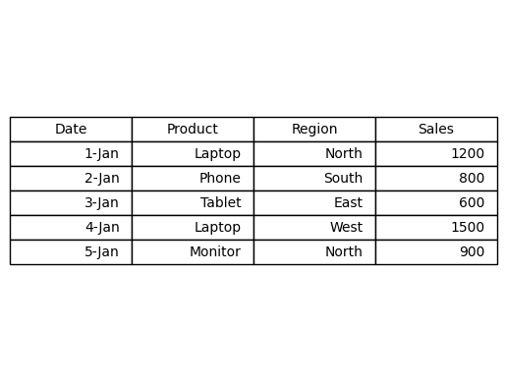

Google Sheets Interface
The interface of Google Sheets is similar to Excel. It includes rows, columns, cells, formula bars, and toolbars. Users can enter formulas, create charts, and analyze datasets.

Common Functions in Google Sheets
Many Excel functions are also available in Google Sheets.
SUM – Calculates totals
AVERAGE – Calculates mean values
COUNT – Counts numeric values
IF – Logical conditional analysis
VLOOKUP – Searches data in tables

Automation and Macros in Google Sheets
Google Sheets supports automation through macros and Google Apps Script. Macros allow users to automate repetitive tasks such as formatting reports, cleaning datasets, or generating dashboards.
Steps to create a macro in Google Sheets:
1. Go to Extensions.
2. Select Macros.
3. Click Record Macro.
4. Perform the task.
5. Save the macro.

Advantages of Google Sheets
• Cloud-based and accessible from anywhere
• Real-time collaboration
• Automatic saving of work
• Easy sharing with teams

Disadvantages of Google Sheets
• Slower performance with very large datasets
• Fewer advanced features compared to Excel
• Requires internet connection for most functionality

Excel vs Google Sheets
Excel is more powerful for advanced analytics, large datasets, and complex dashboards. Google Sheets is better for collaboration, sharing, and cloud-based work environments.

